**Report**

**on**

**FRONT-END ENGINEERING**

**CS186**

by

**Ananya Seth**

**2110990176**

**G5**

**3rd YEAR**

**INSTRUCTOR’S NAME – DR. LAVISH ARORA**

**Batch 2021**

**Session 2023-24**



**Introduction:**

This report outlines the development of a clothing e-commerce website, highlighting the technology stack and procedures for each page, using HTML, CSS, and JavaScript.

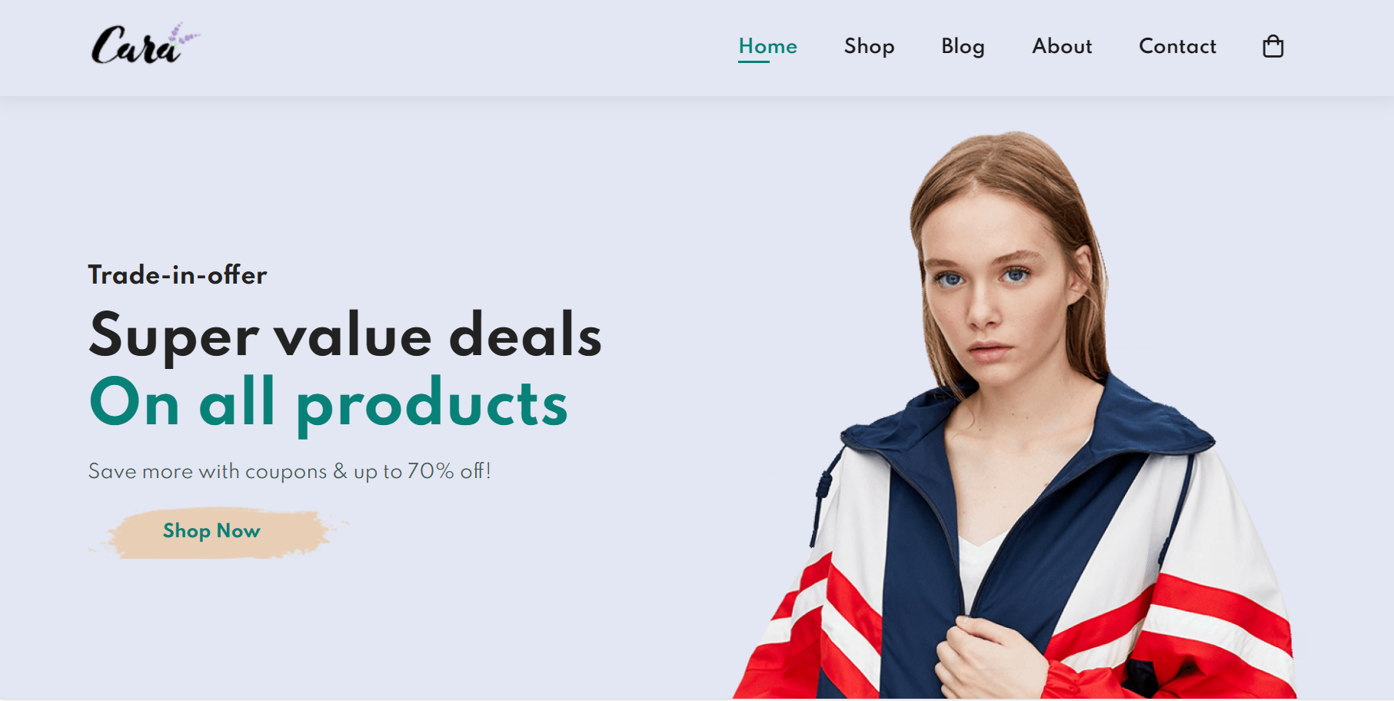

**Technology Stack:**

* Discuss the technology stack used in the project:
* HTML: Used for structuring web pages.
* CSS: Employed for styling and layout.
* JavaScript: Enhanced interactivity and functionality.

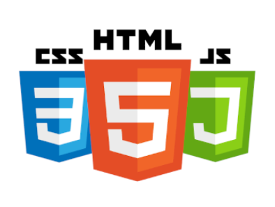

**Home Page**

**Design and Layout**

**The home page serves as the landing page for the website and is designed to capture users' attention. The design includes:**

* A visually appealing hero section showcasing featured products.
* A navigation bar for easy access to other sections of the website.
* Footer with links to important pages (e.g., About Us, Contact, Policies).
* **Development Steps**
* HTML Structure: Create the basic HTML structure for the homepage.
* CSS Styling: Apply CSS styles to layout elements, including the hero section and navigation bar.
* JavaScript Interaction: Implement JavaScript for creating interactive elements like image sliders, featured product displays, and dynamic navigation.



**Shop Page**

**Design and Layout**

**The shop page is where users can browse and search for clothing items. It includes:**

* A grid of product cards, displaying item images, names, prices, and an "Add to Cart" button.
* Sorting and filtering options.
* A search bar for specific product searches.
* **Development Steps**
* HTML Structure: Create the HTML structure for the shop page.
* CSS Styling: Apply CSS styles to format product cards and layout.
* JavaScript Interaction: Implement JavaScript for filtering, sorting, and handling the "Add to Cart" button functionality.

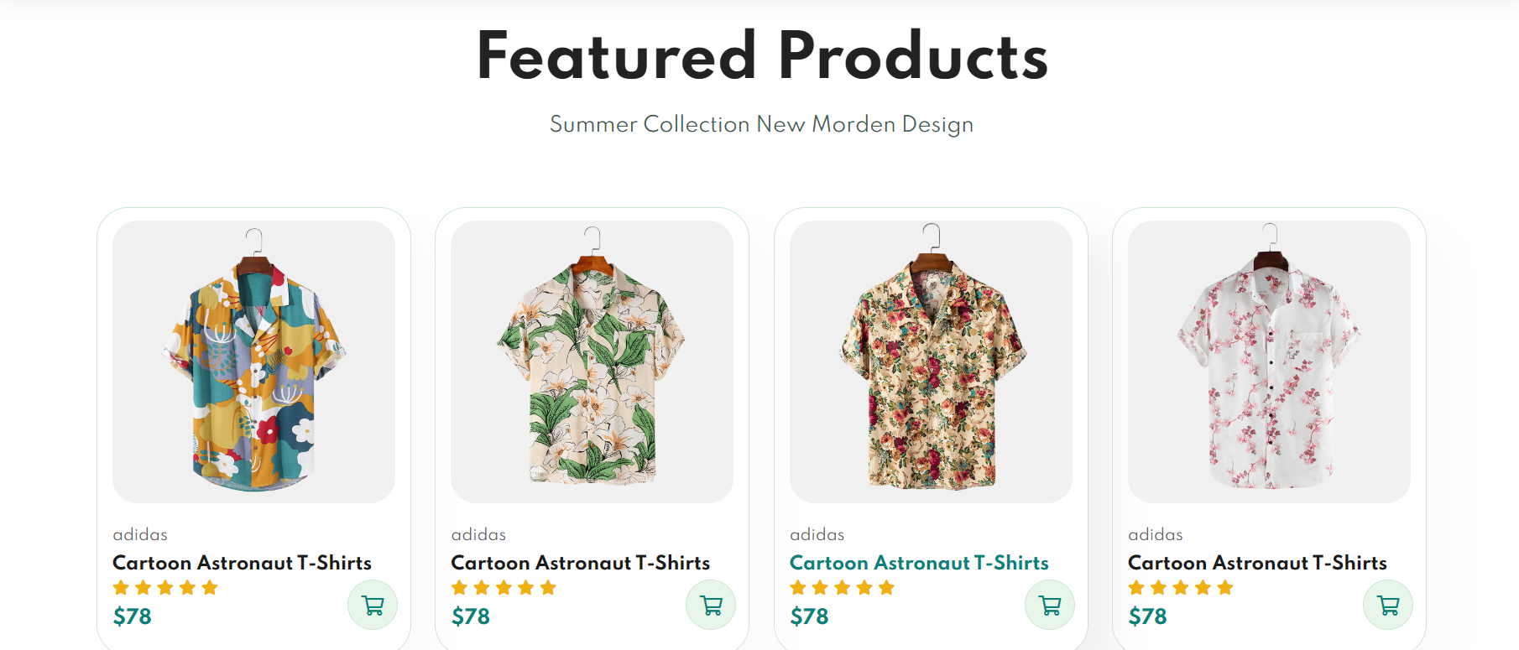

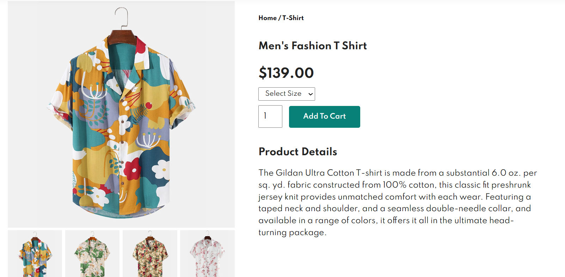

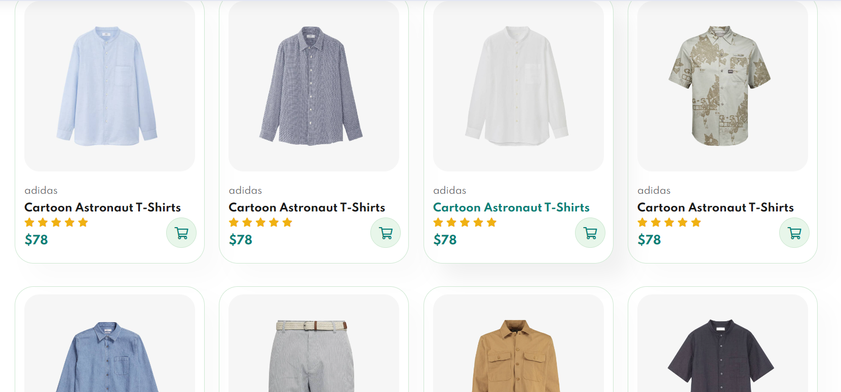

**Blog**

**Design and Layout**

**The blog section is for publishing articles related to fashion and clothing trends. It includes:**

* A list of blog posts with images, titles, excerpts, and read more links.
* A single blog post page with full content.
* **Development Steps**
* HTML Structure: Create HTML templates for the blog listing and individual blog post pages.
* CSS Styling: Apply CSS to style the blog posts and make them visually appealing.
* JavaScript (optional): Use JavaScript for implementing features like comments, sharing, or dynamic content loading if needed.

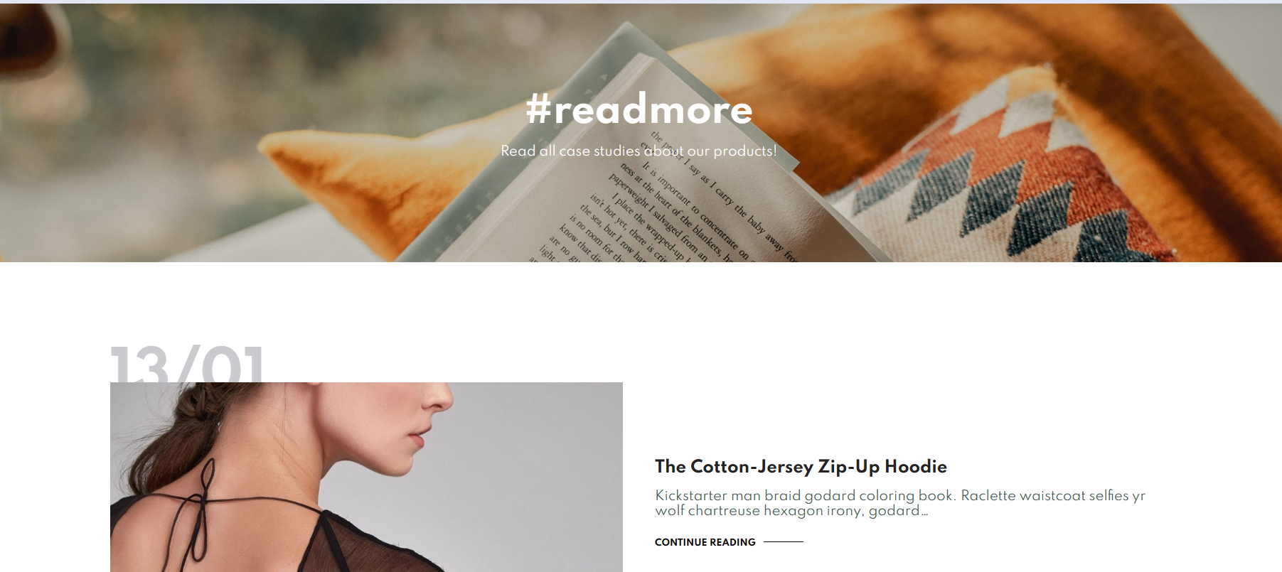

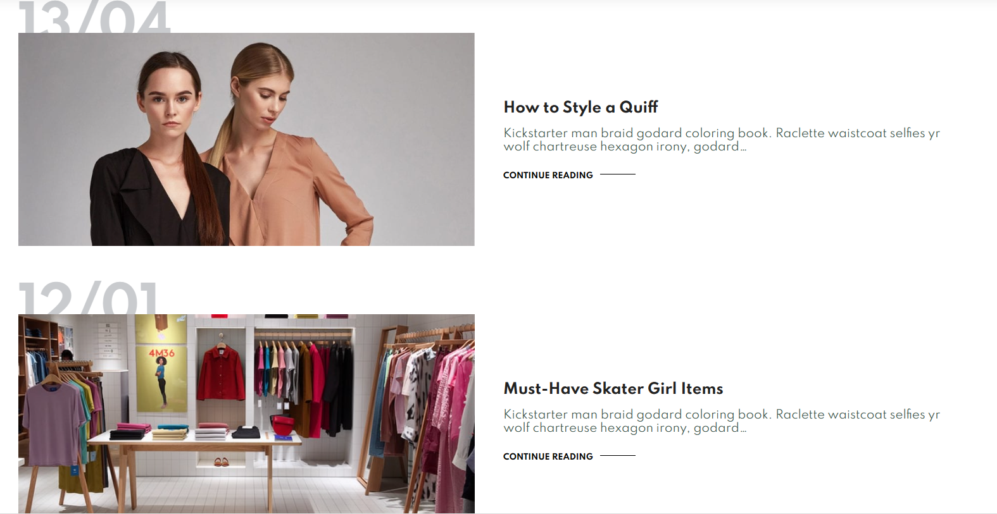

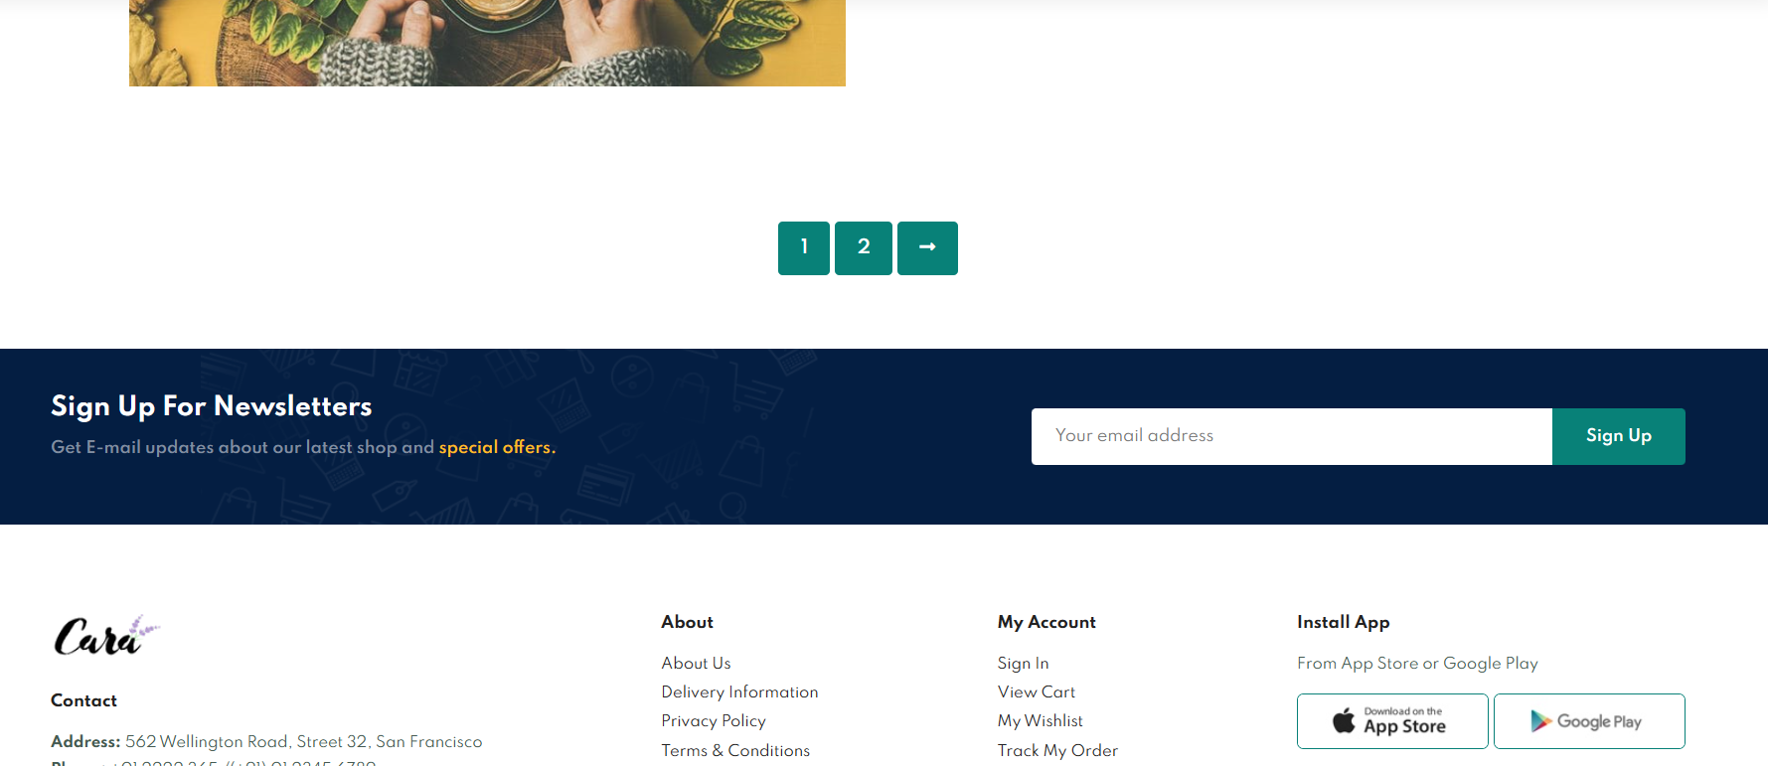

**Cart - Add and Remove Items**

**Design and Layout**

**The cart page displays the items that a user has added for purchase. It includes:**

* A list of items in the cart, each with an image, name, price, quantity, and a "Remove" button.
* Total price and a checkout button.
* **Development Steps**
* HTML Structure: Create an HTML structure for the cart page.
* CSS Styling: Apply CSS styles for cart layout and elements.
* JavaScript Interaction: Implement JavaScript for adding and removing items from the cart, updating quantities, and calculating the total price

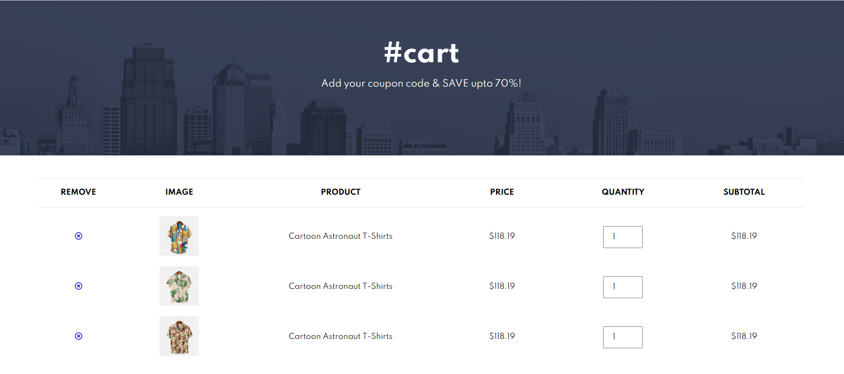.



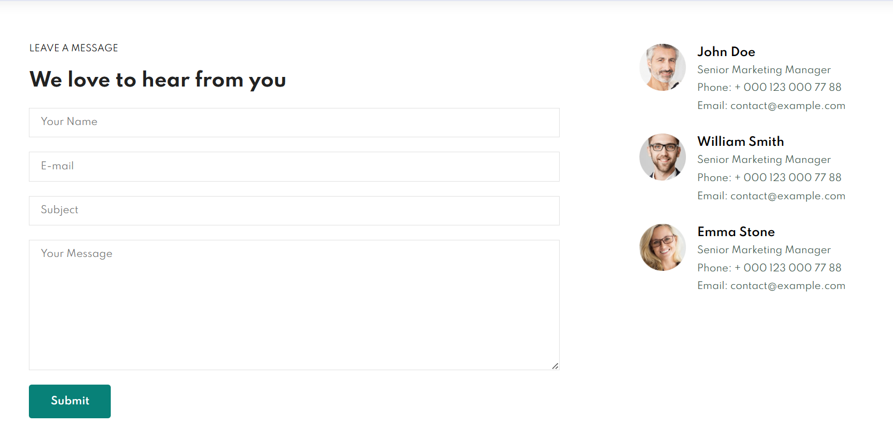

**Conclusion**

This clothing e-commerce website project successfully utilized HTML, CSS, and JavaScript to create a visually appealing, user-friendly, and interactive platform. Further development could include adding a backend for user accounts, order processing, and product inventory management to make it fully functional. The project highlights the importance of a well-thought-out design and the seamless integration of frontend technologies for a great user experience.

**I extend my heartfelt gratitude and special thanks to Dr. Lavish Arora, whose guidance, mentorship, and support were instrumental in the success of this project. Your invaluable insights and expertise have been a driving force throughout the journey.**

**With a keen focus on performance, security, and compliance, our e-commerce platform is poised for growth and poised to meet the evolving needs of our users. It is our hope that this project serves as a foundation for creating exceptional online shopping experiences, fostering user engagement, and ultimately, contributing to the success of our clients and their businesses.**